

**Green University of Bangladesh**

**Department of Computer Science and Engineering (CSE)**

**Faculty of Sciences and Engineering**

**Semester: (Spring, Year:2021), B.Sc. in CSE (Day)**

**LAB REPORT NO: 01**

**Course Title: While and Do -While Loop Control Structure in C**

**Course Code: CSE 104, Section: D8**

**Lab Experiment Name:**

**Introduction to While and Do -While Loop Control Structure in C**

**Student Details**

|  |  |  |
| --- | --- | --- |
| **Name** | | **ID** |
| **1.** | Jahidul Islam | 221002504 |
| **2.** |  |  |
| **3.** |  |  |

**Lab Date : 05/07/2022**

**Submission Date : 14/07/2022**

**Course Teacher’s Name : Mr. Mozdaher Abdul Quader**

**[For Teachers use only: Don’t Write Anything inside this box]**

|  |
| --- |
| **Lab Report Status**  **Marks: ………………………………… Signature:.....................**  **Comments:.............................................. Date:..............................** |

* **TITLE OF THE LAB EXPERIMENT**

1. Write a C program to print all alphabets from a to z.
2. Write a C program to print all even number 1 to 100.
3. Write a C program to enter a number and print its digit in reverse order.
4. Write a C program to find frequency of each digit in a given integer.
5. Write a C program to find sum of first and last digit of any number.
6. Write a C program to swap first and last digits of any number.
7. Write a C program to calculate product of digits of any number.
8. Write a program in C to find the sum of the series 1 +11 + 111 + 1111 + .. n terms.

* **OBJECTIVES/AIM [1]**

1. Print all alphabets from a to z.
2. Print all even number 1 to 100.
3. Enter a number and print its digit in reverse order.
4. Find frequency of each digit in a given integer.
5. Find sum of first and last digit of any number.
6. Swap first and last digits of any number.
7. Calculate product of digits of any number.
8. Find the sum of the series 1 +11 + 111 + 1111 + .. N terms.

* **PROCEDURE / ANALYSIS / DESIGN [2]**

1. Print all alphabets from a to z.

* From the table of Asci we can easily print character.

1. Print all even number 1 to 100.

* We need to use loop called for loop and increment by 1 every time the loop is true for the particular value to print numbers.
* We need to use modulo divison and lower the number every time dividing by 10.

1. Enter a number and print its digit in reverse order.
2. Find frequency of each digit in a given integer.
3. Find sum of first and last digit of any number.
4. Swap first and last digits of any number.
5. Calculate product of digits of any number.
6. Find the sum of the series 1 +11 + 111 + 1111 + .. N terms.

* **IMPLEMENTATION [2]**

I designed the programs in 5 section and separated them using multiline comment.

**TEST RESULT / OUTPUT [2]**

**Code 01:**

**1 #include <stdio.h>**

**2 int main()**

**3 {**

**4 /* program introduction */**

**5 printf("This program print all alphabets from a to z.\n");**

**6 /* required variables*/**

**7 char alphabets;**

**8 /* required input */**

**9 /* calculation */**

**10 for (alphabets = 'a'; alphabets <= 'z'; alphabets++)**

**11 {**

**12 printf("%c ", alphabets);**

**13 }**

**14 /* output section */**

**15 return 0;**

**16 }**

**Code 02:**

**1 #include <stdio.h>**

**2 int main()**

**3 {**

**4 /* program introduction */**

**5 printf("This program print all even number 1 to 100.\n\n");**

**6 /* required variables*/**

**7 int num;**

**8 /* required input */**

**9 /* calculation */**

**10 for (num = 1; num <= 100; num++)**

**11 {**

**12 printf("%d ", num);**

**13 }**

**14 /* output section */**

**15 return 0;**

**16 }**

**Code 03:**

**1 #include <stdio.h>**

**2 int main()**

**3 {**

**4 /* program introduction */**

**5 printf("This program takes a number and print its digit in reverse order.\n");**

**6 /* required variables*/**

**7 int num, remainder, reverse = 0;**

**8 /* required input */**

**9 printf("\nEnter an integer number: ");**

**10 scanf("%d", &num);**

**11 /* calculation */**

**12 /* loop */**

**13 while(num != 0)**

**14 {**

**15 remainder = num % 10;**

**16 reverse = reverse *10 + remainder;**

**17 num /= 10;**

**18 }**

**19 /* output section */**

**20 printf("%d", reverse);**

**21 return 0;**

**22 }**

**Code 04:**

**1 #include <stdio.h>**

**2 int main()**

**3 {**

**4 /* program introduction */**

**5 printf("This program takes a number and print its digit in reverse order.\n");**

**6 /* required variables*/**

**7 int num, one=0, two=0, three=0, four=0, five=0, six=0, seven=0, eight=0, nine=0, ten=0;**

**8 /* required input */**

**9 printf("\nEnter an integer number: ");**

**10 scanf("%d", &num);**

**11 /* calculation */**

**12 /* loop */**

**13 for(;num!=0;num/=10){**

**14 if(num%10==1)**

**15 {one++;}**

**16 if(num%10==2)**

**17 {two++;}**

**18 if(num%10==3)**

**19 {three++;}**

**20 if(num%10==4)**

**21 {four++;}**

**22 if(num%10==5)**

**23 {five++;}**

**24 if(num%10==6)**

**25 {six++;}**

**26 if(num%10==7)**

**27 {seven++;}**

**28 if(num%10==8)**

**29 {eight++;}**

**30 if(num%10==9)**

**31 {nine++;}**

**32 if(num%10==0)**

**33 {ten++;}}**

**34 printf("One : %d\n", one);**

**35 printf("Two : %d\n", two);**

**36 printf("Three : %d\n", three);**

**37 printf("Four : %d\n", four);**

**38 printf("Five : %d\n", five);**

**39 printf("Six : %d\n", six);**

**40 printf("Seven : %d\n", seven);**

**41 printf("Eight : %d\n", eight);**

**42 printf("Nine : %d\n", nine);**

**43 printf("Ten : %d\n", ten);**

**44 return 0;**

**45 }**

**Code 05:**

**1 #include <stdio.h>**

**2 int main()**

**3 {**

**4 /* program introduction */**

**5 printf("This program find sum of first and last digit of any number.\n");**

**6 /* required variables*/**

**7 int num, sum, firstDigit, lastDigit;**

**8 /* required input */**

**9 printf("\nEnter an integer number: ");**

**10 scanf("%d", &num);**

**11 /* calculation */**

**12 lastDigit = num %10;**

**13 /* loop */**

**14 while(num >=10 )**

**15 {**

**16 num /= 10;**

**17 }**

**18 firstDigit = num;**

**19 sum = firstDigit + lastDigit;**

**20**

**21 /* output section */**

**22 printf("%d", sum);**

**23 return 0;**

**24 }**

**Code 06:**

**1 #include <stdio.h>**

**2 #include <math.h>**

**3 int main()**

**4 {**

**5 /* program introduction */**

**6 printf("This program swap first and last digits of any number.\n");**

**7 /* required variables*/**

**8 int num, swapNum, digitsCount, firstDigit, lastDigit, x, y;**

**9 /* required input */**

**10 printf("\nEnter an integer number: ");**

**11 scanf("%d", &num);**

**12 /* calculation */**

**13 digitsCount = log10(num);**

**14 printf("TEST - digitsCount: %d\n", digitsCount);**

**15 firstDigit = num / pow(10, digitsCount);**

**16 printf("TEST - firstDigit : %d\n", firstDigit);**

**17 lastDigit = num %10;**

**18 printf("lastdigit = %d\n", lastDigit);**

**19**

**20 x = firstDigit *(pow(10, digitsCount));**

**21 printf("x = %d\n", x);**

**22 y = num % x;**

**23 printf("y = %d\n", y);**

**24 num = y /10;**

**25 printf("num = %d\n", num);**

**26**

**27**

**28 swapNum = lastDigit * (pow(10, digitsCount)) + (num *10 + firstDigit);**

**29**

**30 /* output section */**

**31 printf("\nThe Number after Swapping First Digit and Last Digit: %d", swapNum);**

**32 return 0;**

**33 }**

**34**

**Code 07:**

**1 #include <stdio.h>**

**2 int main()**

**3 {**

**4 /* program introduction */**

**5 printf("This program product of digits of any number.\n");**

**6 /* required variables*/**

**7 int num, remainder, product=1;**

**8 /* required input */**

**9 printf("\nEnter an integer number: ");**

**10 scanf("%d", &num);**

**11 /* calculation */**

**12 while(num != 0)**

**13 {**

**14 remainder = num % 10;**

**15 product *= remainder;**

**16 num /= 10;**

**17 }**

**18 /* output section */**

**19 printf("The product of digits: %d\n\n", product);**

**20 return 0;**

**21 }**

**22**

**Code 08:**

**1**

**2 #include <stdio.h>**

**3 int main()**

**4 {**

**5 /* program introduction */**

**6 printf("This program find the sum of the series 1 +11 + 111 + 1111 + .. n terms.\n");**

**7 /* required variables*/**

**8 int n, i;**

**9 long sum=0;**

**10 long int t=1;**

**11 /* required input */**

**12 printf("\nEnter an integer number: ");**

**13 scanf("%d", &n);**

**14 /* calculation */**

**15 for(i=1; i<=n;i++)**

**16 {**

**17 printf("%ld ",t);**

**18 if (i<n)**

**19 {**

**20 printf("+ ");**

**21**

**22 }**

**23 sum=sum+t;**

**24 t=(t*10)+1;**

**25 }**

**26 /* output section */**

**27 printf("\nThe Sum is : %ld\n",sum);**

**28 return 0;**

**29 }**

**30**

**Output 01:**

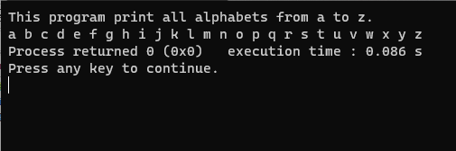

**Output 02:**

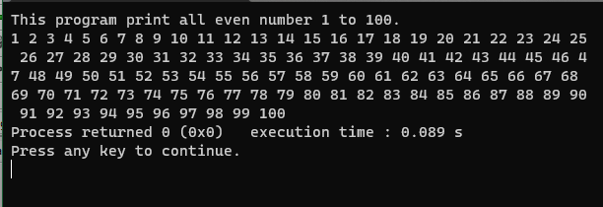

**Output 03:**

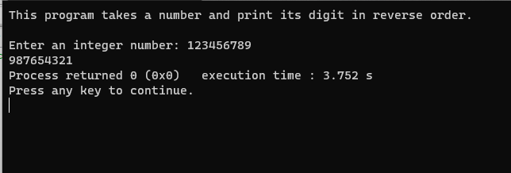

**Output 04:**

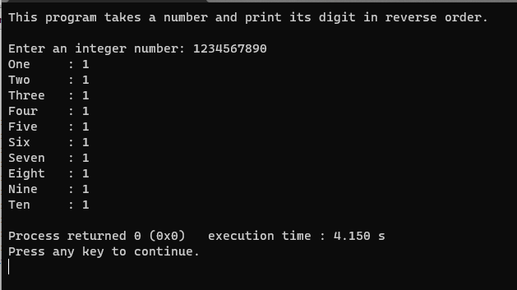

**Output 05:**

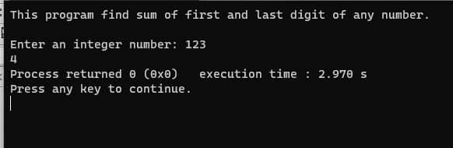

**Output 06:**

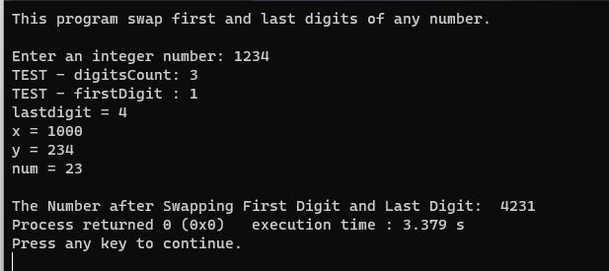

**Output 07:**

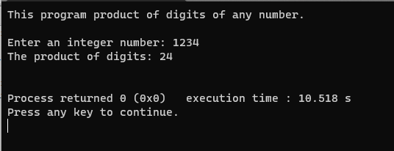

**Output 08:**

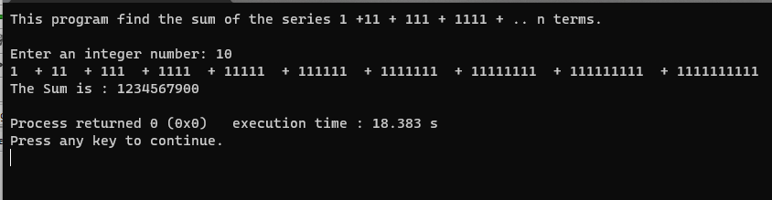

* **ANALYSIS AND DISCUSSION [2]**

These program outputs all the desired result correctly as asked in the manual. It runs well. The trouble spot of these problem is when and where to use the loop and whether it is if – else, else – if ladder, or switch.